The Crypto Effect on Gold and Silver: How Binance Futures Changed Traditional ETFs
Group 4: Yaroslav Kuzmin, Yevhen Nezghovorov, Hlieb Nikoniuk, Tymur Tleuberlin

1. Abstract
The perpetual futures on Gold (XAUUSDT) and Silver (XAGUSDT) launched by Binance in 2026. The paper attempts to examine if these new crypto derivatives affected the stock market specifically gold (GLD) and silver (SLV) ETF. We investigate whether the launch affected the volatility, liquidity, and general trading quality of these ETFs, and whether the crypto markets affect the traditional money markets. To do this, we took over 120 days of data (86 days before and 34 days after launch). One minute dataset with 67000 observations was taken was to study short run correlation and market integration. By looking at what happened before and after something started, we can see this had an impact. The daily price volatility of both GLD and SLV increased significantly, while GLD started exhibiting signs of decreased liquidity.

2. Actualization
To our knowledge, this is the first study to analyze the impact of cryptocurrency derivatives on traditional commodity ETF markets. While most existing studies focus on how Wall Street products (such as Bitcoin ETFs) affect the cryptocurrency market, we are examining the reverse process. We analyze major financial changes occurring in real time using fresh data from January 2026.
Years ago, Wall Street ruled finance while crypto trailed behind like a shadow. Now, signs point both ways - price moves link old markets to digital ones. Strong ties between GLD, SLV ETFs and Binance futures reveal deeper links than before. One world once stood apart; today it helps shape value in physical gold and silver. Trading on crypto platforms shapes commodity prices just as much as trading floors ever did.
What drives this work isn’t just about tactics in trading. Results here matter when it comes to shaping rules and decisions. As cryptocurrency platforms introduce 24/7 trading with high leverage, regulators need to understand how these new platforms are changing existing markets. Our data, which shows that the launch of Binance increased volatility and reduced liquidity in traditional ETFs, serves as a warning. It informs policymakers that risks in the unregulated cryptocurrency sector can easily spill over and disrupt the stability of heavily regulated Wall Street markets.

3. Research Question and Previous Literature
The main question of our research is: Will the introduction of cryptocurrency futures on precious metals lead to increased volatility and reduced liquidity for traditional goldand silver?
Historically, gold and silver have been considered as one of the safest assets. For decades, when the stock market was unstable and unpredictable, investors gave preference to buying traditional ETF such as GLD and SLV to protect their wealth. These traditional markets are highly regulated and operate only during standard Wall Street business hours and generally considered stable.
However, the financial landscape is changing rapidly due to the fast development of Cryptocurrency. Unlike the traditional market, the cryptocurrency market led by platforms such as Binance, operate 24 hours a day, 365 days a year. On January 5, 2026, Binance introduced perpetual futures on gold and silver which allow traders to use high leverage to bet on the price of gold and silver at any time of the day or night.
Launching such a different market, with the traditional market still in operation creates a unique natural experiment and gives an opportunity to find out whether such, easily accessible, and aggressive crypto products diverted attention and stability away from traditional ETFs. By studying this, we can find out whether launching such crypto markets are influencing older, more established financial systems.
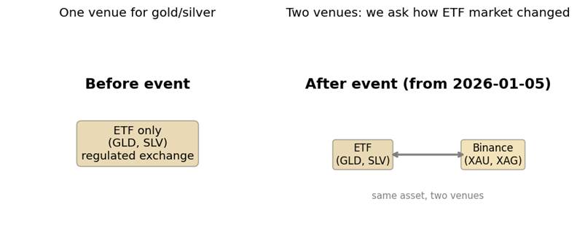
Figure 1: Before the event — one venue (ETFs only); after the event — two venues (ETFs + Binance perpetuals).
Previous literature: Usually when new financial products are created, they change the behavior of the original asset that was operating before it. However, cryptocurrency markets differ from the original market by accessibility and frequency of updating and it is hard to identify direct influence of it. As far as we know, this is the first contender when cryptocurrency entered the traditional market, so at the moment of the research there is no literature related to this case. Instead we found literature that at least have similar concept and which can be useful for us.
Firstly, we looked at literature by Corbett et al. (2018) that shows the opposite situation to ours where futures affect spot markets. Corbett investigated what happened when traditional markets launched Bitcoin futures. Many believed that futures would make Bitcoin safer, but instead futures actually made Bitcoin price fluctuations more extreme. Even though our research asks the opposite question, but at least this article shows the result of how the two markets will interact together and what outcome we can expect.
Secondly, we used a well-known formula created by Yakov Amichai (2002) to understand how easy it is to trade an asset and how to correctly measure liquidity. In its article, Amichai explained that it is not enough to look only at trading volume, instead he created an “illiquidity ratio” that more precisely measures how much the price changes for every dollar. If a small trade causes a large price jump, the market is illiquid and risky.
Hypotheses: To answer our main research question, we are going to test three specific hypotheses that will help us to clearly see how the traditional market’s behavior changed and whether it was caused by new cryptocurrency futures or not.
H1 (volatility): The launch of Binance perpetual futures caused a significant increase in the price volatility of traditional gold and silver.
H2 (volume and liquidity): Trading volume of traditional ETFs increased after Binance launch and made the market less tradable.
H3 (market integration): After the launch, prices of traditional ETFs and new crypto futures became linked and moved together.

4. Data Description
We have collected data of traditional ETF (GLD and SLV) from Yahoo Finance and macroeconomic data (like the VIX fear index and DXY dollar index) from the St. Louis Fed (FRED). Crypto futures data was gathered directly from Binance. We have collected data for different time periods (day-to-date, minute-to-minute). Daily data was used to look at the long-term changes before and after the January launch (per/post mean comparison, t-test, OLS with post event and controls (DXY, VIX, 10Y), while minute data was used to see exactly how prices moved inside a single trading day, intraday return distribution and daily realized volume and rolling correlation.
Source | What we get | Frequency | Rows | Note
Binance API | XAUUSDT, XAGUSDT (OHLCV), funding, OI | 1m | 67k+ | From 2026-01-05 (XAU), 2026-01-07 (XAG)
Yahoo Finance | ETFs: GLD, SLV. Controls: DXY, VIX, TNX. GLD/SLV 1m | Daily; 1m last 7d | 118 daily | 1m only last ~7 days
FRED | DGS10 — 10Y Treasury (macro control) | Daily | in daily panel | Same role as TNX

DXY = dollar index; VIX = volatility index; TNX / DGS10 = 10Y yield

5. Methodology

Volatility
One way to see gold's swings is by checking its behavior before and after January 5th. Some people may say those shifts happened because world markets were shaky that month. Instead of relying on basic average numbers, another path was taken. A technique known as Ordinary Least Squares helped strip away unrelated bumps. Three big-picture economic factors were built into the analysis to keep things grounded
A spike in the VIX - Wall Street’s barometer for fear - usually means chaos is spreading. When investors get nervous, they reach for safer ground. Gold tends to stir during those moments. Turmoil reshapes where money flows. That shift often lifts bullion higher.
When the US Dollar Index moves up or down, it shifts how much gold costs. That happens because gold trades in dollars worldwide.

The TNX (10-Year Treasury Yield): This represents traditional interest rates, which compete with gold for investor money.
By including these variables in our model, we isolated the "Binance Effect." Our results prove that even when you hold the VIX and DXY constant, the launch of the crypto futures still caused a significant spike in ETF volatility. This proves the effect is real and not just a coincidence.
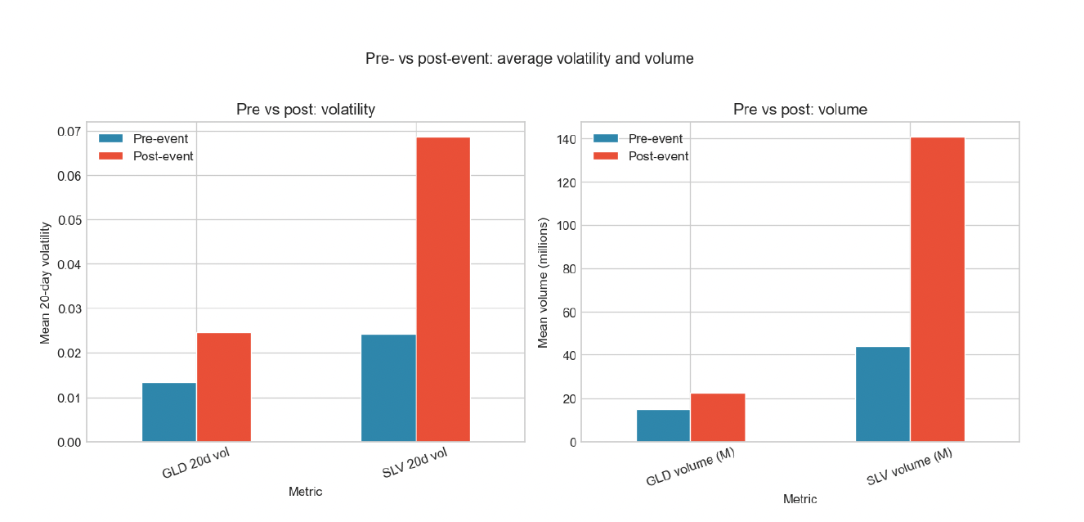
Bar chart of average volatility and volume before and after the event. The jump in the bars after the event is the “effect” we test in regressions.
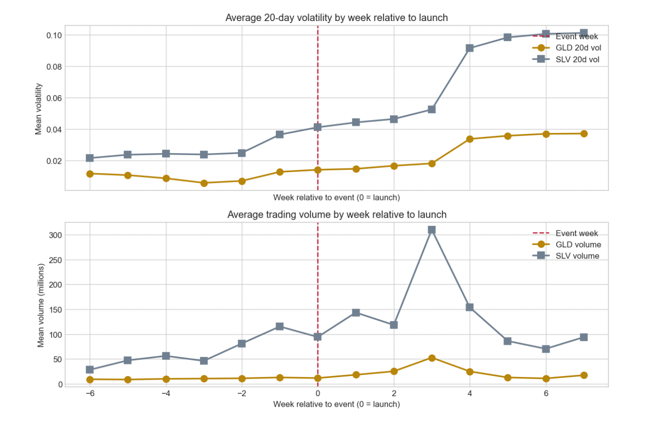
Dynamics around the event: average outcome by week relative to the launch (week 0 = event week). This shows whether the change is immediate or builds over time.
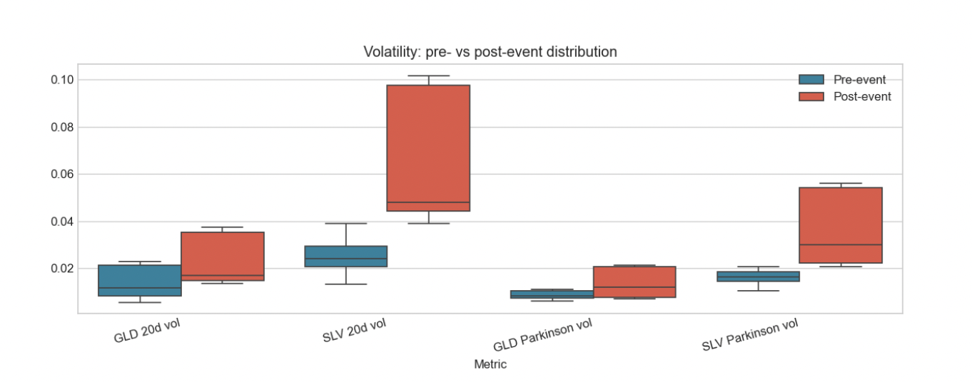
Pre vs post distributions for key metrics (boxplots by period).

Liquidity
Most people think that if an asset has high trading volume, it is highly liquid and safe to trade. Yakov Amihud's 2002 research proved this is a misconception. True liquidity means you can trade a massive amount of assets without changing its price.
To measure this, we calculated the Amihud Illiquidity Ratio for every day in our dataset by taking the absolute daily price return and divide it by the total dollar volume traded that day.
Low Amihud score – millions of dollars changed hands, but the price barely moved (healthy, highly liquid market).
High Amihud score – small amount of trading volume caused the price to jump wildly (dangerous, illiquid market).
To check if the traditional Wall Street market and the new crypto market were ignoring each other or working together, we measured the price correlation between the GLD and SLV ETFs and the new Binance futures.
We used a T-test to make sure our findings were real and statistically significant.

6. Results

Finding 1: Volatility Spiked
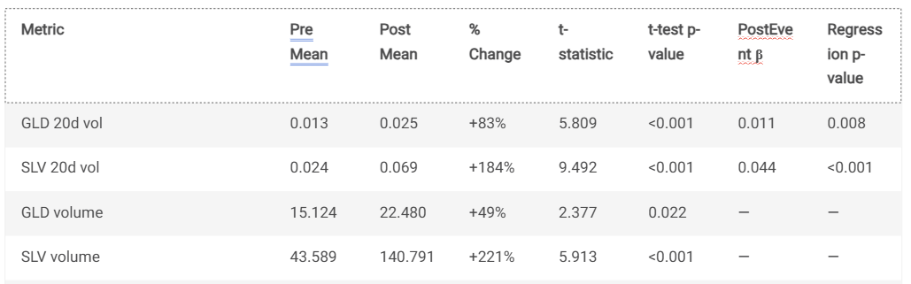
- For the Gold ETF, the average volatility jumped from 0.013 before the launch to 0.025 after.
- For the Silver ETF, it nearly tripled, jumping from 0.024 to 0.069.
We found a massive difference between the Pre-Launch and Post-Launch periods. After Binance launched its futures, the daily trading volume for the traditional ETFs exploded.
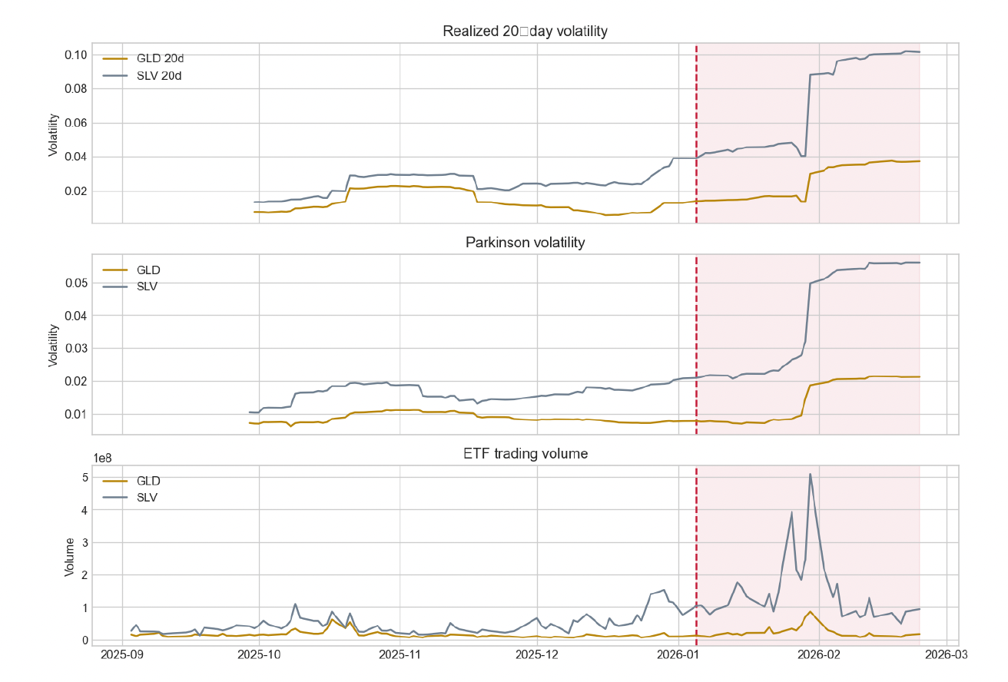
The average trading volume for Gold ETF increased by 49%.
The average trading volume for Silver ETF increased by an astonishing 221%.

Finding 2: The Liquidity Drain
Normally, when trading volume goes up, investors assume the market has become healthier and more liquid. However, our Amihud Illiquidity tests showed that the market actually became harder to trade without moving the price. This is a fascinating paradox: the Binance launch brought a huge amount of new trading energy and volume to the stock market, but it made the market's underlying structure less stable.
We also regress Amihud illiquidity and log(volume) on the event and controls. A negative coefficient on post_event for Amihud would indicate improved liquidity (lower illiquidity) after the launch; a positive coefficient for log_vol would indicate higher volume.
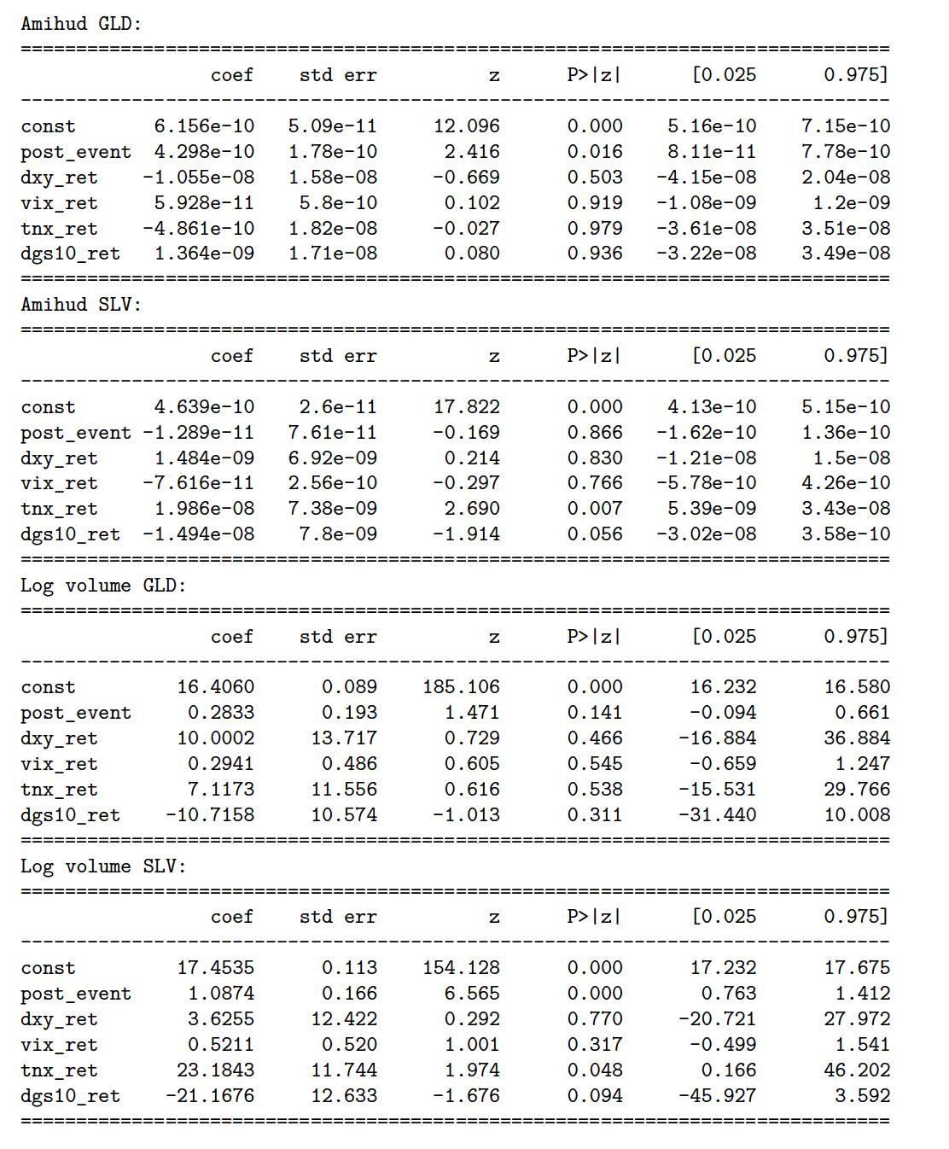

Finding 3: Market Integration and Correlation
Our data showed a massive level of market integration. The 20-day rolling correlation between the traditional ETFs and the Binance futures stayed consistently between 0.92 and 0.94. This is an incredibly high score. It proves that the two markets are deeply connected. When the price of gold changes on the 24/7 crypto exchange, the traditional Wall Street ETF immediately copies that movement.
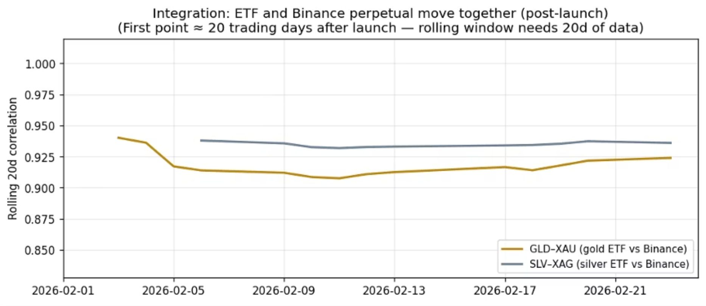
For the most recent 7 days we have minute-level data for both ETFs (Yahoo) and Binance. We merge on datetime and compute 1m returns to get a same-frequency measure of short-run co-movement.
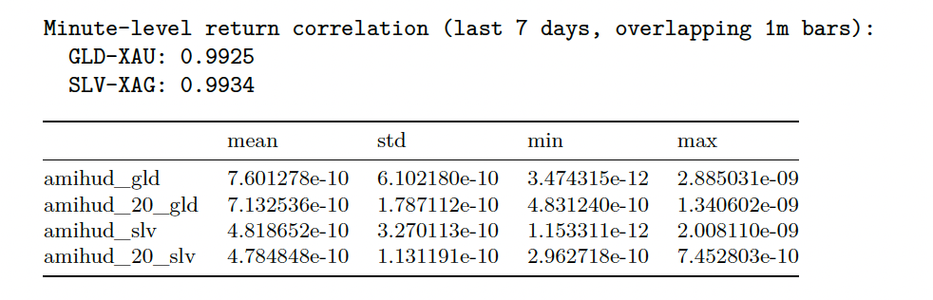

Finding 4: Deep Gold and Silver analysis
When we looked at the GLD ETF after the Binance launch, we noticed a strange paradox. The average daily trading volume actually increased. On the surface, a casual observer would say the ETF became healthier. However, our Amihud Illiquidity calculations revealed the exact opposite. The illiquidity score for GLD almost double. It means while more shares were trading, the trades were causing much larger price disruptions.
We theorize that sophisticated "market makers" and algorithmic arbitrage traders migrated some of their capital to Binance, where they could trade 24/7 with higher leverage. This left the traditional GLD ETF with less structural support. When regular investors traded GLD on Wall Street, there were fewer institutional safety nets to absorb their trades, causing the price to swing more violently.
Interestingly, the Silver ETF told a slightly different story. While its volatility tripled just like Gold's, its Amihud illiquidity score did not show a statistically significant worsening. This divergence makes economic sense. Silver is heavily used in industrial manufacturing (like solar panels and electronics), meaning its physical market is vastly different from Gold's, which is mostly driven by investment and jewelry. Silver's traditional ETF market may be more anchored by industrial hedgers who are less likely to migrate to a crypto exchange like Binance.

Finding 5: Correlation
The most important takeaway from the matrix is the incredibly high correlation between the traditional assets and the newly launched crypto derivatives during the post-event overlap. Specifically, the GLD ETF moves in near lockstep with the Binance Gold futures, and the SLV ETF shows the same strong relationship with Binance Silver futures. This data acts as visual proof of our market integration hypothesis. It confirms that the traditional Wall Street market and the 24/7 crypto market are not operating in isolation; they are deeply connected and actively pricing the same global information.
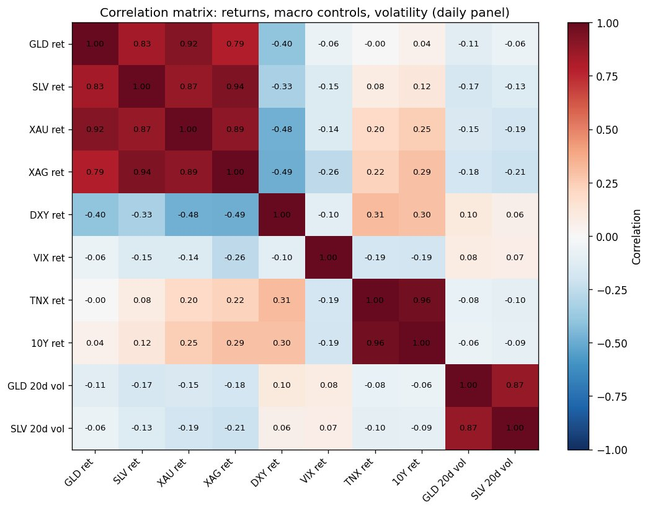
We can also see that these global forces as VIX (general stock market fear) and the DXY (US Dollar strength) naturally push and pull the price of gold and silver. Seeing these relationships in the matrix confirms that including them in our OLS regressions was the right choice.

7. Economic Interpretation: Why Did This Happen?
Arbitrage traders are sophisticated investors who look for tiny price differences between two markets. Because Binance futures trade 24 hours a day with high leverage, and GLD only trades during normal stock market hours, price gaps constantly appear between the two. When the Wall Street market opens, arbitrage traders rush in to buy or sell an ETF to close the gap with the Binance price.
This behavior perfectly explains our data. The rush of arbitrage traders caused the massive spike in trading volume we observed (+49% for GLD and +221% for SLV). Furthermore, because these traders are aggressively forcing the ETF to catch up to the crypto market's price, they cause the ETF's volatility to spike. Ultimately, the traditional ETF is no longer setting its own price; it is simply reacting to the shocks and discoveries made in the crypto market overnight.

8. Conclusions
Our data tells a clear story: the launch of Binance Gold and Silver futures disrupted the traditional stock market. First, crypto derivatives brought more volatility to the traditional ETFs. While trading volume went up, the actual ease of trading for Gold worsened.
As a result, we can say that buying a traditional Gold ETF is no longer such safe investment it used to be. Because crypto markets are trading these assets 24/7 with high leverage, retail investors holding GLD or SLV will experience rougher price swings during standard market hours. To invest successfully, ETF market makers need to adjust their risk models. They must now monitor Binance funding rates and crypto volumes to predict how traditional ETFs will behave when the opening bell rings in New York.

9. Limitations & Future research
While our dataset includes over 70,000 observations, it is important to acknowledge the limitations of this study. The Binance gold and silver futures were launched very recently, on January 5, 2026. Therefore, our "Post-Launch" window only covers a short period. It is possible that the extreme volatility and volume spikes we observed were a temporary "launch shock" as traders tested the new crypto product.
Future research should revisit this topic with a full year of data to see if the traditional ETFs calm down, or if high volatility is the permanent new normal. Additionally, future studies should analyze exactly how the overnight hours (when the US stock market is closed) affect the opening prices of the ETFs, to better understand how 24/7 crypto markets handle global news compared to traditional finance.

10. References
- Amihud, Yakov. "Illiquidity and Stock Returns: Cross-Section and Time-Series Effects." Journal of Financial Markets 5, no. 1 (2002): 31-56.
- Corbet, Shaen, Brian Lucey, Maurice Peat, and Samuel Vigne. "Bitcoin Futures—What Use Are They?." Economics Letters 172 (2018): 23-27.

11. Technical Appendix
1. Amihud Illiquidity Ratio To measure liquidity, we used the Amihud formula. It is calculated as the absolute value of the daily return divided by the daily dollar trading volume. Illiquidity = | Daily Return | / Daily Volume
2. Statistical T-Test To compare the Pre-Launch and Post-Launch periods, we used Welch's T-test. This tests if the averages of two groups are significantly different. We considered any result with a p-value under 0.05 to be statistically significant, meaning there is less than a 5% chance the difference happened by accident.

